Crowd:came

Based on zone

"countThreshold": {

"ZoneCrowd": 10

}

"fps": "1/4" - can 1 frame per 2 to 5 seconds

"alert_interval": 150,

"ViolationFrameCount": 15,

ViolationFrameCount – Must be atleast 15 seconds to confirm alert. It can be more than 15 seconds in my opinion.

Loitering:

"fps": "5/1"

"loiteringThresholdSeconds": 20,

"alert_interval": 40,

LoiteringThresholdSeconds – Based on the viewpoint

Parking Violation:

"fps": "5/1" can be “2/1”

"loiteringThresholdSeconds": 60,

"resetSeconds":10 – Not sure about this

Fire Detection:

"fps": "2/1" or “1/2” or “1/1”

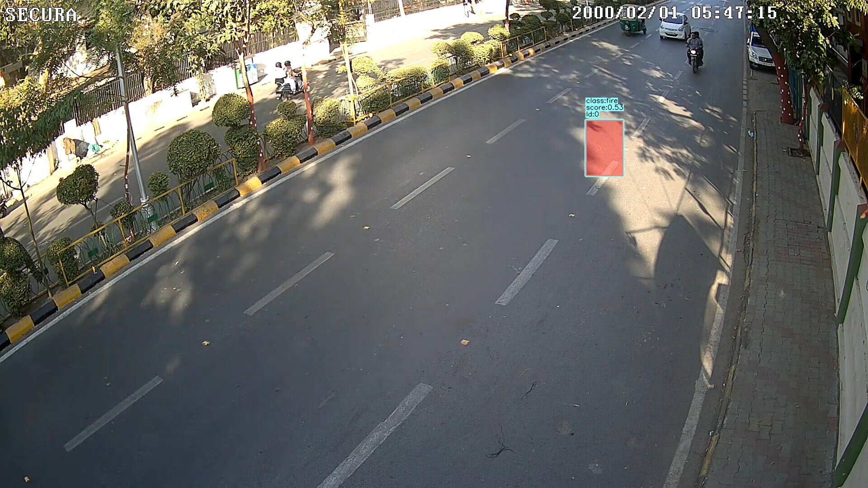

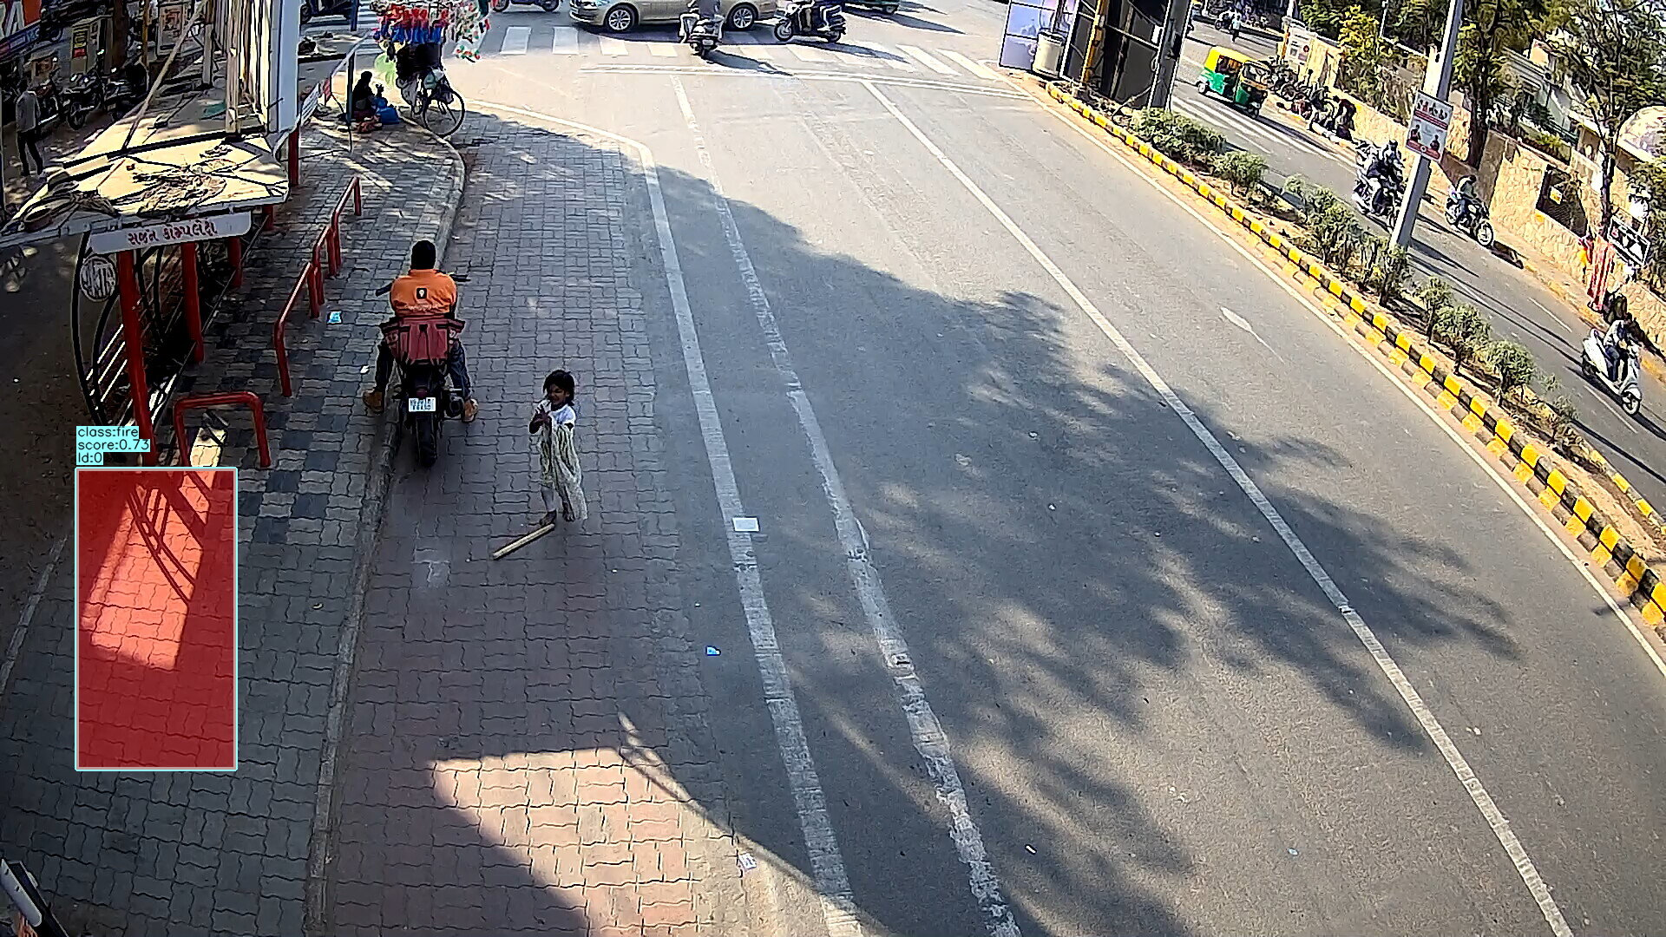

Model Resolution: "width": 1024, "height": 1024,

Decoder: "decoder_width": 1024,"decoder_height": 704,

"conf": 0.70,

"frameCountThresh":5,

"alert_interval": 30,

FrameCountThresh – based on the Frames per second atleast for 15 seconds

Above resolutions can be used for little closer cameras also.

Abandoned Object:

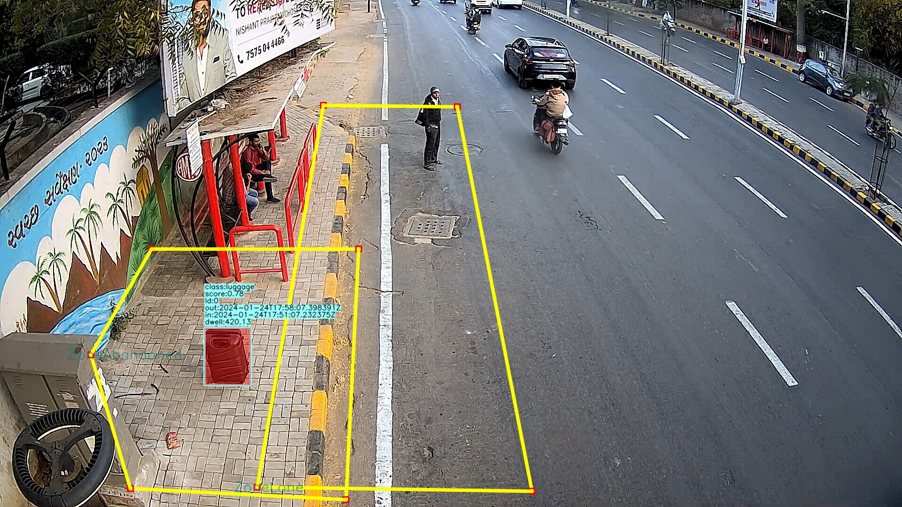

"fps": "5/1" can be “2/1”,”1/1”

General Object Detection:

Model: "width": 896,"height": 896,

Decoder: "decoder_width": 896,"decoder_height": 608,

"conf": 0.70,

Luggage Detection

Model: "width": 896,"height": 896,

Decoder: "decoder_width": 896,"decoder_height": 608,

"conf": 0.70,

If the views are bigger as in Fire detection and bags need to be detected at Far area,then

Model Resolution: "width": 1024, "height": 1024,

Decoder: "decoder_width": 1024,"decoder_height": 704,

"conf": 0.70,

Associate policy: should allow bags from General Object Detection also

Usecase:

"timeThreshold":120, 60/120 seconds (about 1 to 2 minutes) is reasonable

distance_ratio: 1 to 2 – This can be increased to 2 or 1.5 to be sure of “abandoned bag”

**Weapon Detection**

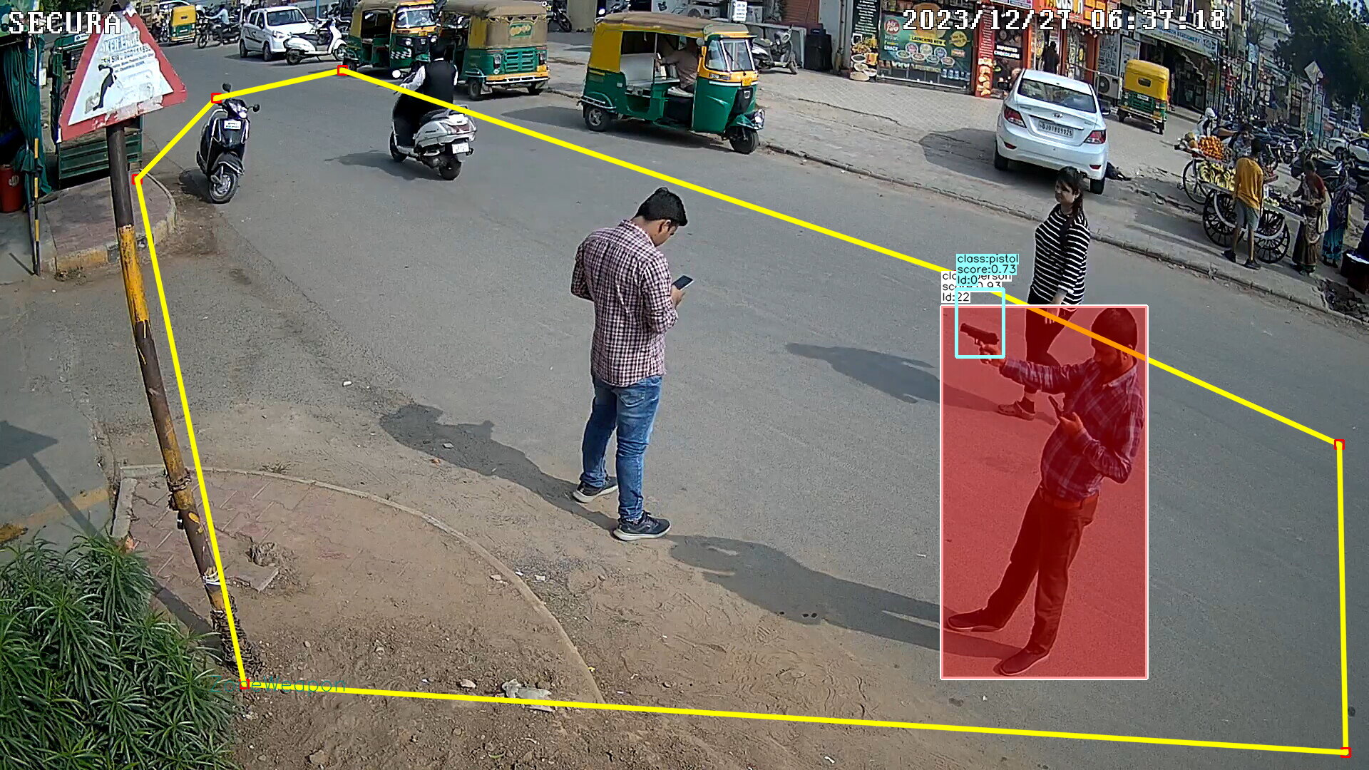

"fps": "5/1" can be “2/1”,”1/1”

Weapon Detection Model:

Model: "width": 896,"height": 896,

Decoder: "decoder_width": 896,"decoder_height": 608,

"conf": 0.70,

If the views are bigger as in Fire detection and weapons need to be detected at Far area,then

Model Resolution: "width": 1024, "height": 1024,

Decoder: "decoder_width": 1024,"decoder_height": 704,

"conf": 0.70,

"withoutAssociationObjectsNeeded":"False",

"frameCountThresh": should be equivalent to atleast 3 to 5 seconds

"alert_interval": 30,

Fall Detection:

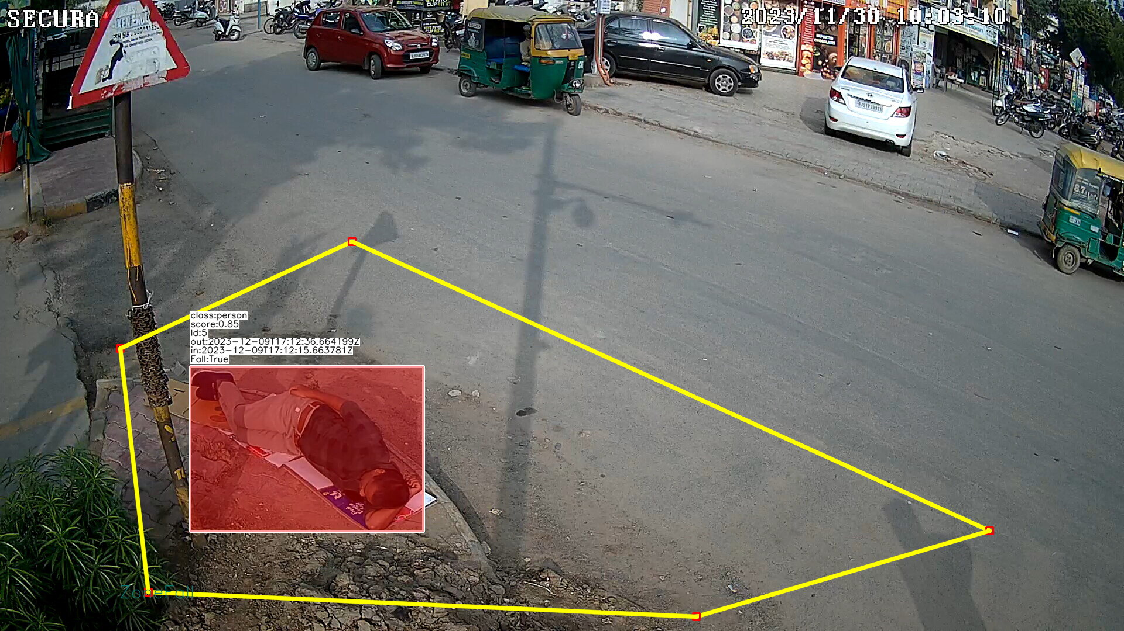

"fps": "5/1" can be “2/1”,”1/1”

Fall Detection Model:

Model: "width": 896,"height": 896,

Decoder: "decoder_width": 896,"decoder_height": 608,

"conf": 0.70,0.75

If the views are bigger as in Fire detection and fall needs to be detected at Far area,then

Model Resolution: "width": 1024, "height": 1024,

Decoder: "decoder_width": 1024,"decoder_height": 704,

"conf": 0.70,0.75

For Gneral obj: resolution:1920x1080 model=640x640

Usecase:

"fallConfidence":0.7 to 0.75,

"personConfidence":0.5,

"associate": "False",

"fall_time":can be atleast 60 seconds to detect people lying down,for sudden fall it can be 15 seconds

"non_fall_time":2, - Not required for now,if required based on the view can be atleast 2 seconds

"alert_interval": 300,

Leaning Detection:

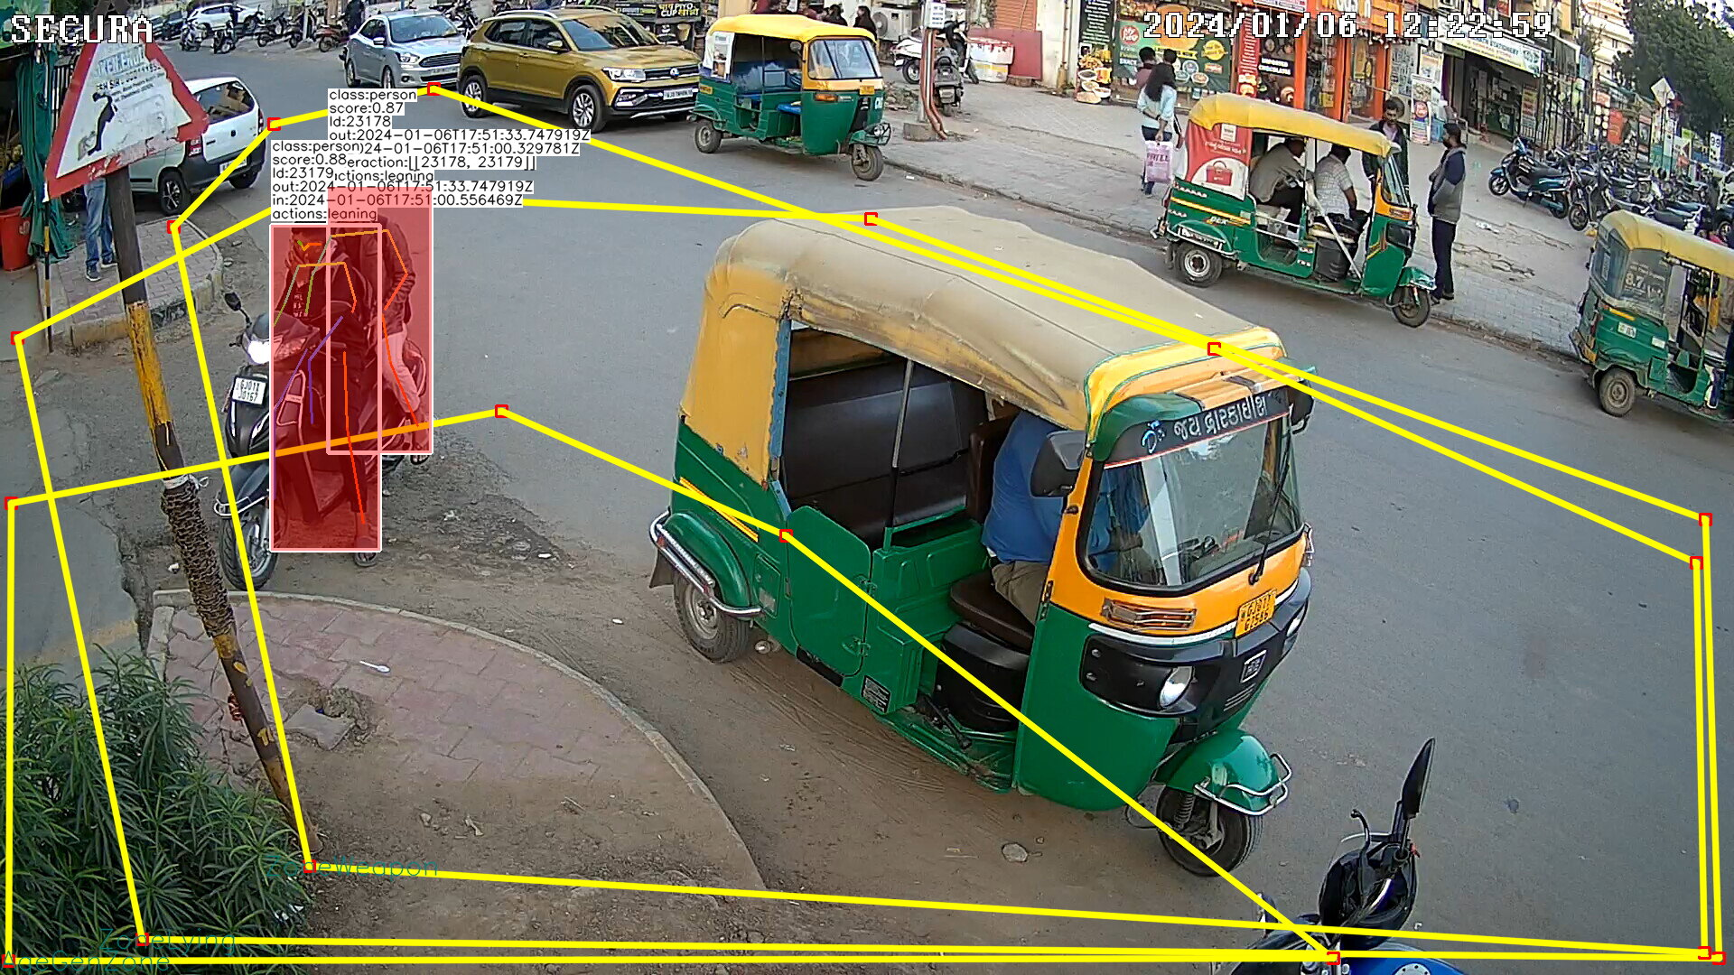

"fps": "5/1" can be “2/1”,”1/1”

"decoder_width": 640,

"decoder_height": 360,

Below sizes are advisable as it is pose estimation of fixed size – better not to go below 960x960

"decoder_width": 1920

"decoder_height": 1080

Interaction Policy:

"activity_type":["action","interaction"],

"selected_keypoints":{"p1":["right_elbow","left_elbow"],"p2":["right_shoulder","left_shoulder"]},

"threshold":20,

"N_violating_keypoints":1,

Usecase:

"voting": 3, required only for gender check is True – Should be equivalent of 15 seconds in terms of number of frames

"gender_check": "False",

"waitSecondsForAction":60, - Leaning atleast for 60 seconds – even if it missed inbetween it is fine or there is no leaning also fine –

"ppl_violating_count":2, - Not used for now

"alertable_actions":["leaning"],

"alert_interval":600,

CHAIN SNatching

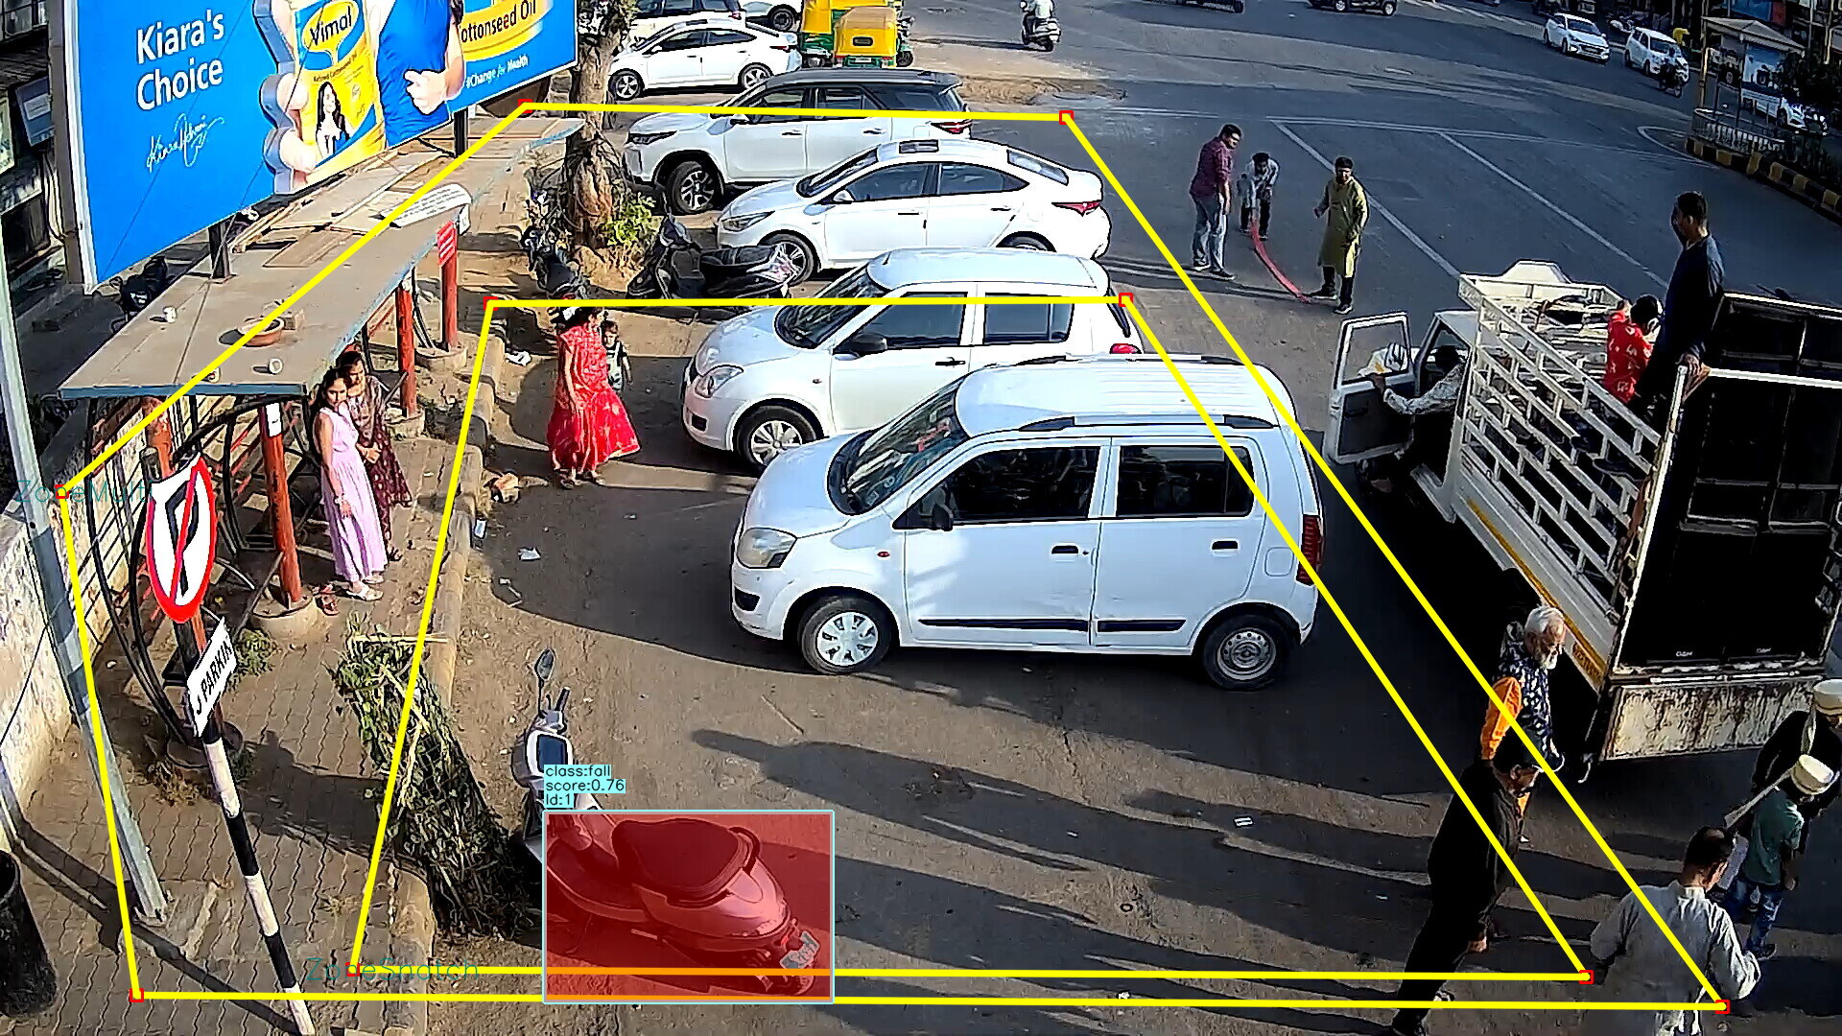

"decoder_width": 640,

"decoder_height": 360,

Below sizes are advisable as it is pose estimation of fixed size – better not to go below 960x960

"decoder_width": 1920

"decoder_height": 1080

For fall detection refer Fall Detection Usecase

Other data are fine as in 0016_snatchingDetection_camera_118_71_rec.json set2 of Ahmedabad

Fight Detection( WILL UPDATE LATER FURTHER)

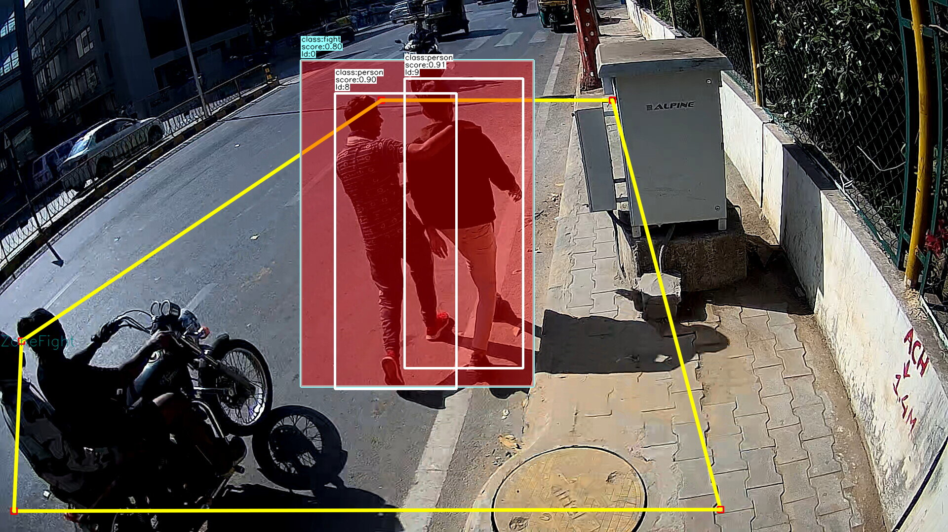

"fps": "5/1" can be “2/1”,”1/1”

Model Resolution can be increase to 896x896 to reduce false positives

"pplInteractionRequired":"True",

"frameCountThresh":100,

Fight Det:

"conf": 0.25,

"iou": 0.45

Pose:

"decoder_width": 1920,

"decoder_height": 1080,

"conf": 0.05,

"nms_iou": 0.35

Fastmot Tracker:

Settings:

{

"width":1920,

"height":1080,

"obj_name":"general",

"max_age":9,

"age_penalty":2,

"motion_weight":0.4,

"max_assoc_cost":0.8,

"max_reid_cost":0.6,

"iou_thresh":0.4,

"duplicate_thresh":0.5,

"occlusion_thresh":0.4,

"conf_thresh":0.15,

"confirm_hits":1,

"history_size":50,

"detector_skip_frame":1,

"decoderType": "TURBO",

"interpolationType": "INTERP_GAUSSIAN",

"batch_size": 1,

"enable_batching": true

},

Params:

"max_age":9,

"age_penalty":2,

"motion_weight":0.4,

"max_assoc_cost":0.8,

"max_reid_cost":0.6,

"iou_thresh":0.4,

"duplicate_thresh":0.5,

"occlusion_thresh":0.4,

"conf_thresh":0.15,

"confirm_hits":1,

"history_size":50,

"detector_skip_frame":1,

"decoderType": "TURBO",

"interpolationType": "INTERP_GAUSSIAN"

Policy1:

{

"key": "person_kps_conf_filter",

"params": {

"confidence":0.15,

"min_low_confidence_keypoints":2

}

},

{

"key": "action_sequence",

"params": {

"activity_type":["action"],

"actions":["fight"]

}

}

Policy2:

{

"key":"associate",

"params": {"type":"iou","sort":"descending","preprocess":{},

"selection":["many"],"comparisons":[["fight","person"]],

"iou":0.01,"postprocess":{"primary":"fight","policy":"filter","filter_params":[">","1"]}

}

}

Usecase Params:

"params": {

"min_fight_duration":3,

"distance_threshold":12,

"strict":false,

"no_fight_tolerance_duration":2,

"alert_interval": 5,

"severity": "high"

}

LONE WOMEN DETECTION/MEN IN WOMEN

bodygender

Conf:

“female”: 0.95/0.98 to 1.0

“male”: 0.95 to 1.0

Face+body model

Need to experiment more – for now we can keep 0.7 as confidence in usecase code

Usecase: Below needs to be discussed with Kini

"frameCount": 30,

"genderProposalRatio": 0.8,

"genCountRatioThresh": 0.7,

"alertType": ["loneWomen"],

"trackerIdBased": "True",

"alert_interval": 600,

sfall

llfa

Face Detection:

"pixel_hthresh": 80 to 150, the current value of 30 is too low

"pixel_wthresh": 80 to 150

gender_conf – No parameter like this

"voting":10 – should be equivalent to 3 to 5 seconds in terms of number of frames

"window_length":15, - should be equivalent to 3 to 5 seconds in terms of number of frames

**Camera Tampering:**

**FPS: “5/1”**

**Settings:**

"decoder_width": 640,

"decoder_height": 360

Parameters:

"scenechange_threshold" : 70, #alert will occur when more than this

"scenechange_min_scene_len" : 10,

"blurThreshold" : 140, #alert will occur when less than this

"blurnessFrameCountThresh" : 10,

"brightPixelRatio" : 0.13, #alert will occur when more than this

"brightnessFrameCountThresh" : 10,

"darknessThresh" : 0.30, #alert will occur when less than this

"darknessFrameCountThresh" : 5,

"dimDark" : 10,

Congestion:

**FPS: “5/1”**

**Rectangular Zone on road is required**

**Paramters**:

"caliberations":[{"zone":"CongestionZone","slots":1,"position":"mid","countThreshold":14,"alertSlotCount":1}],

number of slots is based on view point. 1 is Ideal and alertSlotCount=1 is ideal scenario. CountThreshold should be decided on area that a slot covers in real world. The vehicle category is filtered by policy.

"historyLength":10, #for stationary calculation

"stationaryThreshold":25, #for stationary calculation, number of pixel variation for mean of center point of ROIs, if within this then vehicle is considered as stationary.

**Indexing common object:**

**FPS: “5/1”**

**Use general object detection model**

"decoder_width": 640,

"decoder_height": 360,

**parameters:**

"sizeChangeType":"height", #other options are “width”,”area”.

"sizeChangePerc":50, #when height of Object changes by 50%, then second time logging of object ROI will happen

**Tracker:**

If usecase is like stationary based – like parking violation,leaning etc then,

FPS can be 1/1, 2/1

"ttl": 4,

"tracker_type": "NONE",

"keep_upper_height_ratio": 1.0,

"iou": 0.45,0.7

"sigma_iou": 0.3,

"sigma_h": 0.3,

"sigma_l": 0.1,

"t_min": 1

**If Usecase is moving like loitering,**

FPS can be 8/1, 5/1

"ttl": 4,

"tracker_type": "NONE",

"keep_upper_height_ratio": 1.0,

"iou": 0.45,0.25

"sigma_iou": 0.3,

"sigma_h": 0.3,

"sigma_l": 0.1,

"t_min": 1

Fast moving objects:

Use Fastmot